Management Africa Got Talent Project
Postal address: P.O Box 358-00100,Nairobi
events@talentafricamanagement.org
inquiries@talentafricamanagement.org
Tel: 0721115111
Location : Safari Park View Estate

MANAGEMENT AFRICAN TALENT SHOW REPORT
DATE: 13th JUNE 2024
LOCATION: CARNIVORE SIMBA SALOON
PREPARED BY: GRACE MWANGI

BACKGROUND
Management African Got Talent Project is a Non-Governmental Organization (NGO) dedicated to identifying, nurturing, and showcasing the abundant talents of African youth. Established with the vision of providing a platform for young individuals to express their creative abilities and gain recognition, the NGO focuses on a diverse range of talents including music, dance, art, and performance. The project aims to empower youth by offering them opportunities to shine on a regional and international stage, thereby fostering personal growth, boosting self-confidence, and promoting cultural heritage.
EXECUTIVE SUMMARY
Management African Talent Show Event, held on 13 JUNE 2024, was a resounding success, providing a vibrant platform for 14 talented contestants to showcase their skills. Sponsored by Management African Got Talent Project, Managemente Synergy sponsers the event with entertainment services Mentes Collection,Carnivore Restaurant, and Cowboys and CowGirls Apparel, the event attracted a diverse audience and generated significant interest and enthusiasm. This report provides a detailed overview of the event, including its objectives, challenges faced, recommendations for future events, and a concluding summary of outcomes.
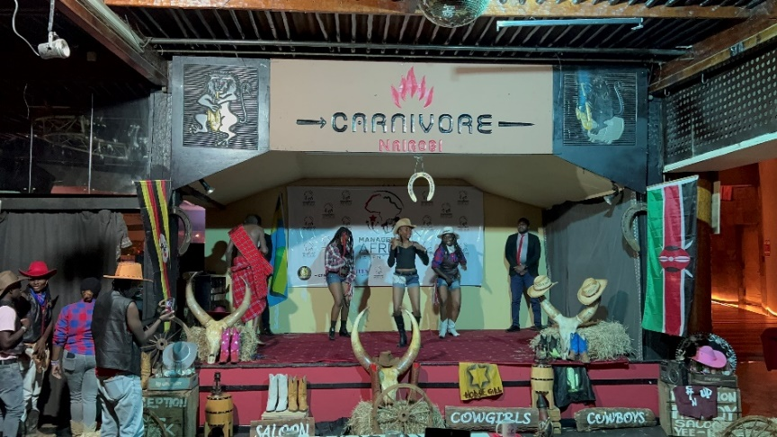
Main Sponsor: Management African Got Talent Project (MAGTP)
- Contribution: As the primary sponsor and organizer, MAGTP oversaw the event's planning, logistics, and overall execution, ensuring a seamless experience for participants and attendees alike.
Key Sponsors and Their Contributions:
- Management Synergy:
  - Contribution: Provided essential entertainment services including public address systems, guest artist performances, and set designing.
  - Impact: Elevated the event's entertainment value and production quality, creating a captivating atmosphere for all participants and spectators.
- Mentes Collection:
  - Contribution: Sponsored the event by outfitting MAGTP staff in traditional attire and designer clothing.
  - Impact: Enhanced the visual appeal of the event while promoting cultural diversity through fashion, reflecting the richness of African heritage.
- Carnivore Kenya:
  - Contribution: Offered the venue for auditions.
  - Impact: Provided a spacious and conducive environment for auditioning participants, ensuring efficiency and comfort during the preliminary rounds.
- Cowboys and Cowgirls Apparel:
  - Contribution: Provided cowboy-themed attire for MAGTP staff and contributed to set design.
  - Impact: Infused a distinctive theme into the event, enriching its visual identity and thematic coherence, thereby enhancing the overall experience
INTRODUCTION
Management African Talent Show is part of an ongoing effort by the Management African Got Talent Project to provide young talents with the exposure they need to advance their careers. The event took place at Carnivore Simba Saloon, bringing together a blend of sponsors, participants, and an enthusiastic audience. It served as a testament to the rich pool of talent in the region and highlighted the importance of creating platforms for youth empowerment.
OBJECTIVES
• To provide a platform for talented youth to showcase their abilities.
• To identify and nurture young talents in various fields such as music, dance, and performance arts.
• To enhance the visibility of young talents and provide them with opportunities for career advancement.
• To promote cultural diversity and appreciation through various talent presentations.
• To engage the community and foster a supportive environment for youth development.

IMPACT
1.Talent Discovery and Development
The event successfully identified several promising talents who displayed exceptional skills. Participants received positive feedback and valuable advice from experienced judges, which will help them in their future endeavors.
2.Community Engagement
The talent show fostered a sense of community and togetherness. It brought together people from different backgrounds, promoting social cohesion and mutual support.
3.Media Exposure
The participants got media exposure from the official social media platforms of the talent show hence showcasing their talent to a whole new audience.
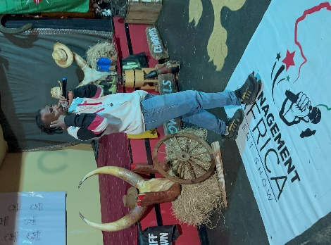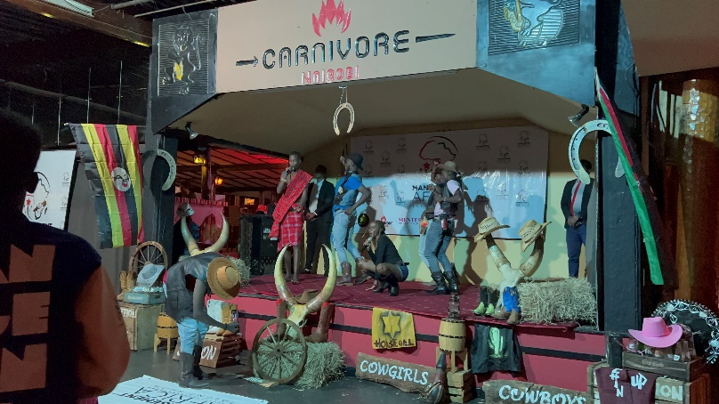

CHALLENGES
• Logistical Issues: Ensuring smooth coordination among sponsors and participants presented logistical challenges.
• Technical Difficulties: Occasional technical glitches affected the seamless execution of performances.
• Time Management: Managing the schedule to accommodate the contestants and performances within the allocated time frame was challenging.Due to participants being late
• Resource Constraints: Limited resources impacted certain aspects of event management, including stage setup and promotional activities.
RECOMMENDATIONS
• Enhanced Planning: Implement detailed planning sessions well in advance of the event to streamline logistics and coordination.
• Technical Support: Invest in robust technical support to mitigate potential glitches and ensure smooth performance flow.
• Time Management: Develop a more structured schedule with clear time allocations for each performance to avoid overruns.
• Resource Allocation: Secure additional resources and sponsorships to improve stage setup, promotional activities, and overall event experience.
• Feedback Mechanism: Establish a feedback mechanism to gather input from participants, audience, and sponsors to identify areas for improvement.
CONCLUSION
Management African Talent Show Event successfully highlighted the extraordinary talents of 14 young contestants, fulfilling its mission of providing a platform for youth to showcase their skills. Despite facing some challenges, the event was well-received and achieved its primary objectives. Moving forward, incorporating the recommendations outlined in this report will enhance the effectiveness and impact of future events. The continued support from sponsors such as Management Synergy, Carnivore Restaurant, and Cowboys and Cow Girls Apparel will be crucial in sustaining the momentum and success of this initiative.
By nurturing and showcasing young talents,Management African Got Talent Project continues to play a pivotal role in empowering the next generation and promoting cultural richness within the African continent.

……………………………….……….END OF REPORT……………………………………………

