Management Africa Got Talent Project
Postal address: P.O Box 358-00100,Nairobi
events@talentafricamanagement.org
inquiries@talentafricamanagement.org
Tel: 0721115111
Location : Safari Park View Estate

MANAGEMENT AFRICAN TALENT SHOW REPORT
DATE: 20th JUNE 2024
LOCATION: CARNIVORE MOTORSPORT ROOM
PREPARED BY: GRACE MWANGI

BACKGROUND
Management African Got Talent Project (MAGTP) is a non-governmental organization dedicated to identifying, nurturing, and promoting talent across Africa.MAGTP operates with a mission to empower individuals with exceptional artistic abilities, providing them with platforms to showcase their talents on both local and international stages.
EXECUTIVE SUMMARY
Management African Got Talent Project (MAGTP) hosted the third talent show at Carnivore Motorsport Room.The purpose of the show was to provide a platform for talented individuals to showcase their abilities. The audition phase attracted 18 contestants,16 from Nairobi county,1 from Samburu county and Nyeri county.14 artists, 2 DJs, and 2 dancers participated in the audition. This report outlines the outcomes, challenges faced, and recommendations for future events.
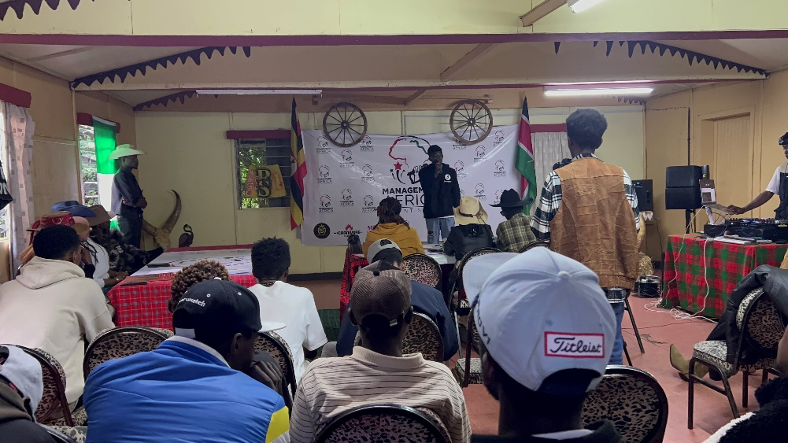

Main Sponsor: Management African Got Talent Project (MAGTP)
- As the main sponsor and organizer, MAGTP facilitated the entire event, overseeing logistics, contestant management, and overall event coordination.
Key Sponsors and Contributions:
- Management Synergy:
  - Contribution: Provided comprehensive entertainment services including public address systems, guest artists performances, and set designing.
  - Impact: Enhanced the event's ambiance and entertainment value, ensuring a memorable experience for attendees and participants alike.
- Mentes Collection:
  - Contribution: Sponsored the event by dressing MAGTP staff in traditional attires and designer clothes.
  - Impact: Added cultural richness and aesthetic appeal to the event, showcasing diverse African fashion and promoting cultural heritage.
- Carnivore Kenya:
  - Contribution: Provided the venue for auditions.
  - Impact: Offered a spacious and suitable location for preliminary rounds, facilitating a smooth audition process for aspiring contestants.
- Cowboys and Cowgirls Apparel:
  - Contribution: Supplied cowboy attire for MAGTP staff and contributed to set designing.
Impact: Infused a unique theme and visual style to the event, creating a vibrant atmosphere and reinforcing the event's theme.
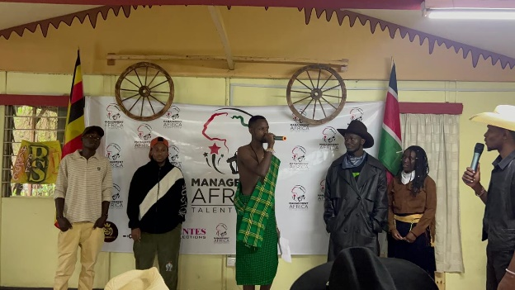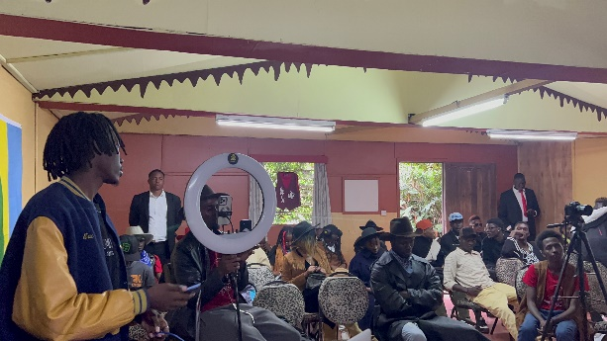
INTRODUCTION
Management African Got Talent Project is dedicated to promoting and nurturing talent across Africa. Supported by various sponsors, our initiative aims to discover, support, and elevate the next generation of talented individuals. The talent show serves as a pivotal opportunity for contestants to gain exposure and recognition on a broader stage.
OBJECTIVES
• To provide a platform for talented individuals to showcase their skills.
• To promote cultural diversity and creativity through arts and entertainment.
• To foster collaboration between sponsors and local communities in supporting talent development initiatives.

IMPACT
The talent show witnessed a significant impact on both participants and the community:
- Participant Development: Contestants gained valuable experience and exposure, enhancing their confidence and skill set.
- Community Engagement: The event brought together diverse talent from Nairobi ,Samburu and Nyeri counties, highlighting the cultural richness of the region.
- Sponsor Contribution: Sponsors played a crucial role in facilitating the event, demonstrating their commitment to nurturing talent in Africa.

CHALLENGES
Despite its success, the project encountered several challenges:
Logistical Constraints: Managing the show required meticulous planning and coordination.
- Resource Limitations: Limited financial resources impacted the scale and outreach of the event.
- Technical Issues: Technical glitches during performances occasionally disrupted the flow of the show.
RECOMMENDATIONS
Based on the experience gained, the following recommendations are proposed for future editions:
- Enhanced Sponsorship: Seek additional sponsors to expand financial and logistical support.
- Improved Planning: Develop a detailed timeline and contingency plans to mitigate logistical challenges.
- Technical Support: Invest in better technical equipment and expertise to ensure seamless execution of the event.
CONCLUSION
In conclusion,Management African Got Talent Project’s event was a resounding success, thanks to the generous support of sponsors like Management Synergy,Mentes Collection,Carnivore Kenya, Cowboys and Cowgirls Apparel.The talent showcased by contestants from Nairobi,Samburu and Nyeri counties underscored the wealth of creativity and potential within these communities. Moving forward, we remain committed to advancing our mission of empowering African talent and look forward to organizing more impactful events in the future
……………………………….……….END OF REPORT……………………………………………

