Management Africa Got Talent Project
Postal address: P.O Box 358-00100,Nairobi
events@talentafricamanagement.org
inquiries@talentafricamanagement.org
Tel: 0721115111
Location : Safari Park View Estate

MANAGEMENT AFRICA TALENT SHOW REPORT
DATE: 16th MAY 2024
LOCATION: 1ST MUGUMOINI DRIVE
PREPARED BY: GRACE MWANGI

BACKGROUND
Management Africa Got Talent Project(MAGTP) is a non-governmental organization committed to discovering and nurturing talent across the African continent. Established with the goal of providing a platform for individuals to showcase their unique abilities, the organization hosts events and programs aimed at talent development and recognition. On 16th May 2024,Management Africa Got Talent Project organized a talent show at 1st Mugumoini Drive in Nairobi, Kenya, attracting a wide array of participants and an enthusiastic audience. 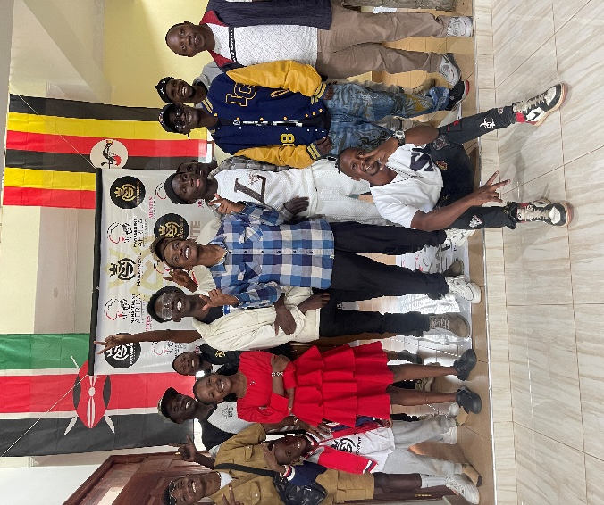
EXECUTIVE SUMMARY
This report presents an overview of the talent show organized by Management Africa Got Talent Project, an NGO dedicated to nurturing talent across Africa. The event took place on May 1, 2024, at 1st Mugumoini Drive, Nairobi. The show showcased a diverse range of talents, providing participants with a platform to display their skills and gain recognition. This report covers the background, introduction,objectives,implementation,impact, challenges, recommendations, and conclusion of the even
INTRODUCTION
The talent show held on 16th MAY 2024, was organized to identify and promote local talent in Nairobi. It attracted participants from different parts of the city, with performances comprising of mostly singing. The event was attended by artists and representatives from various organizations. The primary objective was to create a platform for young talents to gain exposure and receive constructive feedback from a panel of judges.
OBJECTIVES
The primary objectives of the talent show were
1.To provide a competitive platform for talented individuals to showcase their skills
2.To promote cultural diversity and appreciation of different art forms
3.To identify and nurture emerging talent in various fields
4.To foster a supportive community for artists across Africa
5.To award the most outstanding performer at the end of every month
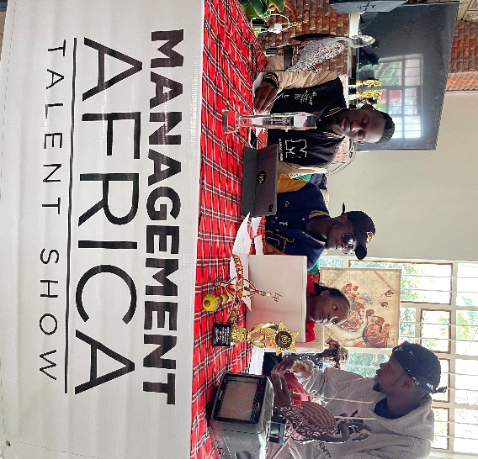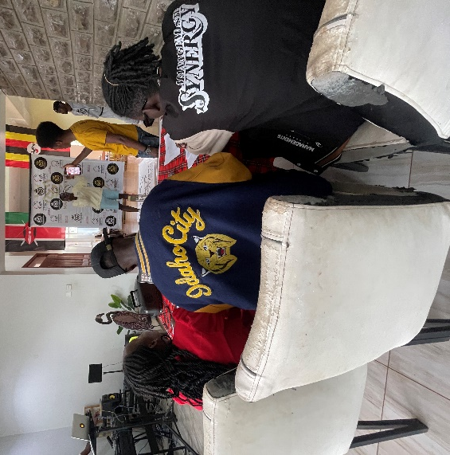
IMPLEMENTATION
The talent show was meticulously planned and executed by Management Africa Got Talent Project team. Tasks included venue arrangements, participant registrations, judge selection, and promotional activities. The event featured performances from participants mainly musicians.A panel of judges evaluated the performances based on criteria such as creativity, skill, and stage presence.
IMPACT
1.Talent Discovery and Development
The event successfully identified several promising talents who displayed exceptional skills. Participants received positive feedback and valuable advice from experienced judges, which will help them in their future endeavors.
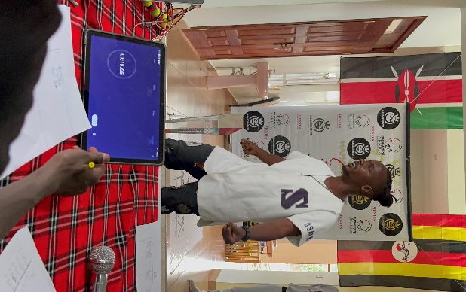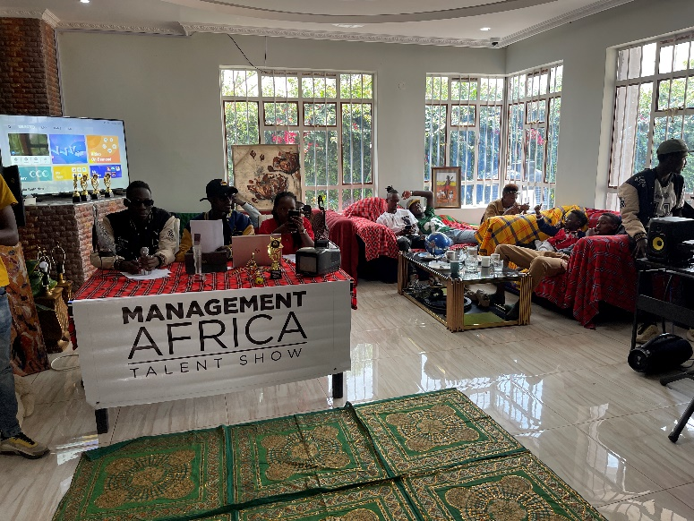
2.Community Engagement
The talent show fostered a sense of community and togetherness. It brought together people from different backgrounds, promoting social cohesion and mutual support.
3.Media Exposure
The participants got media exposure from the official social media platforms of the talent show hence showcasing their talent to a whole new audience.
CHALLENGES
1.Funding Constraints
Securing adequate funding for the event was a major challenge. Limited financial resources restricted the scale of the event that could be provided to participants.
2.Logistical Issues
Coordinating the event logistics for the participant posed a challenge since they all came from different areas.Despite these challenges, the team managed to execute the event successfully.
3.Participant Turnout
While the turnout was impressive, there were instances of participants canceling at the last minute, which affected the overall schedule and flow of the event.
4.Technical Glitches:
technical glitches such as power outages, equipment malfunctions, or connectivity issues occured unexpectedly, potentially disrupting the smooth flow of the event and causing delays.
5.Stage Management Challenges:
Coordinating multiple acts, stage transitions, and technical cues within tight timeframes requires meticulous planning and effective communication among stage managers, performers, and crew members to ensure smooth execution and minimize disruptions.
6.Post-Production Challenges
Editing and post-production work following the event, including video/audio editing, color correction, and distribution of media content, can be time-consuming and resource-intensive, requiring meticulous attention to detail to ensure the final product meets the desired standards of quality and professionalism.
RECOMMENDATIONS
1.Increased Funding and Sponsorship
To enhance future events, efforts should be made to secure more funding and sponsorships. This could involve partnering with local businesses and seeking grants from international organizations.
2.Improved Logistics Planning
Investing in better logistical planning and equipment will ensure smoother execution of events. This includes better sound and lighting systems, as well as efficient stage management.
3.Enhanced Participant Engagement
To minimize last-minute cancellations, it is recommended to implement a more robust participant confirmation process and provide incentives for commitment.
CONCLUSION
The talent show at First Mugumoini Drive was a significant success, highlighting the immense talent present in Nairobi. Despite facing some challenges, the event achieved its primary objectives of talent discovery and community engagement. With the lessons learned and the recommendations provided, future events can be even more impactful and well-organized, furthering the mission of the Africa Got Talent Project.
The Africa Got Talent Project remains committed to nurturing talent and providing opportunities for young individuals to shine. The success of this talent show is a testament to the potential that lies within our communities, and we look forward to organizing more such events in the future.

