Management Africa Got Talent Project
Postal address: P.O Box 358-00100,Nairobi
events@talentafricamanagement.org
inquiries@talentafricamanagement.org
Tel: 0721115111
Location : Safari Park View Estate

NGO WEEK REPORT
DATE: 19th JUNE 2024
LOCATION: KICC,NAIROBI
PREPARED BY: GRACE MWANGI

BACKGROUND
Management African Got Talent Project is a non-governmental organization dedicated to discovering and nurturing talent across the African continent.MAGTP has focused on empowering young people through various artistic and creative endeavors, aiming to provide them with platforms to showcase their talents and access opportunities for growth and development.
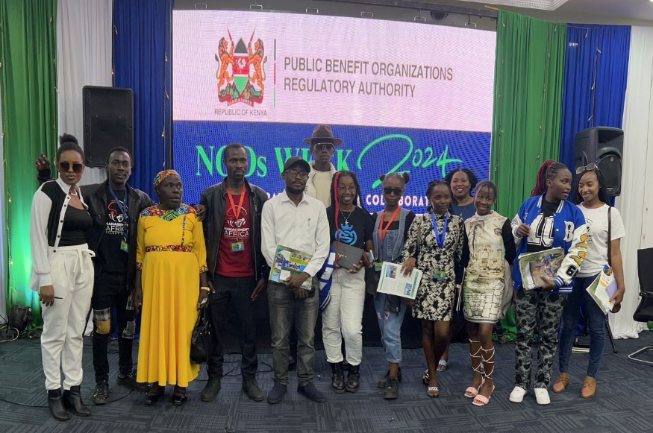
EXECUTIVE SUMMARY
The NGO Week official opening at the Kenya International Convention Center (KICC) marked a significant milestone for MAGTP. This event provided a unique opportunity for MAGTP members to engage with peers from other NGOs, fostering valuable collaborations, knowledge exchange, and potential partnerships. The event was instrumental in expanding MAGTP's network and reinforcing its commitment to talent development across Africa.

INTRODUCTION
The NGO Week at KICC brought together a diverse range of NGOs, each contributing to various social causes and initiatives across the region. For MAGTP, participating in this event was crucial not only for networking but also for gaining insights into best practices and innovative approaches within the NGO sector..
OBJECTIVES
• Networking: Facilitate interactions between MAGTP members and representatives of other NGOs to explore collaboration opportunities.
• Learning: Gain new perspectives and knowledge from workshops, seminars, and discussions held during the NGO Week.
• Partnerships: Identify potential sponsors and partners who align with MAGTP's mission and vision for talent development in Africa.
IMPACT
The participation of MAGTP in the NGO Week yielded several significant impacts:
- Enhanced Networking: MAGTP members engaged with over 50 other NGOs, fostering relationships that may lead to future collaborations.
- Knowledge Exchange: Attending workshops and seminars provided MAGTP with valuable insights into fundraising, project management, and advocacy strategies.
- Potential Partnerships: Identified several organizations interested in supporting MAGTP's initiatives financially or through in-kind contributions.
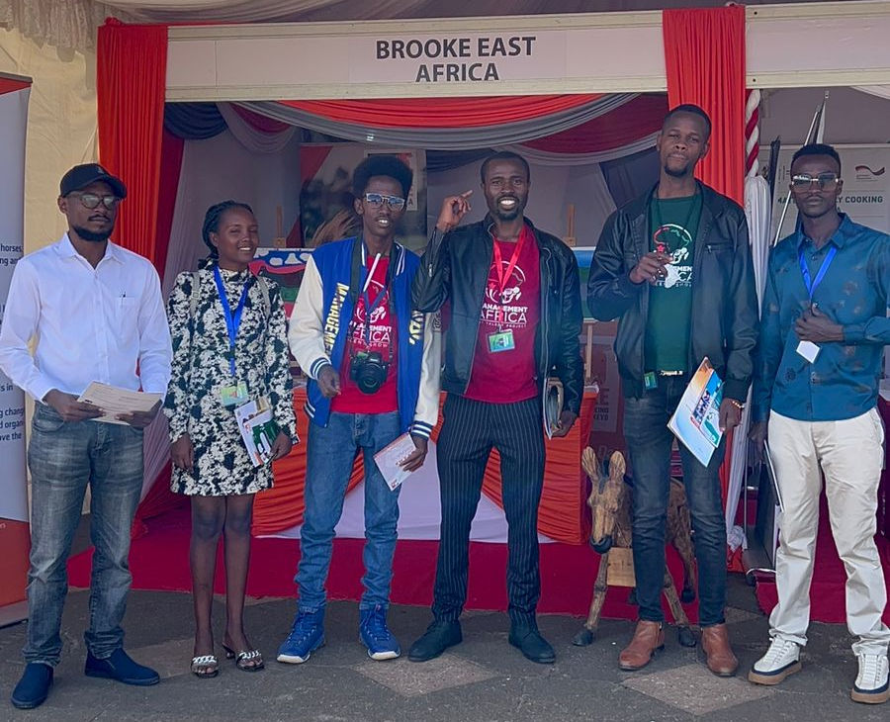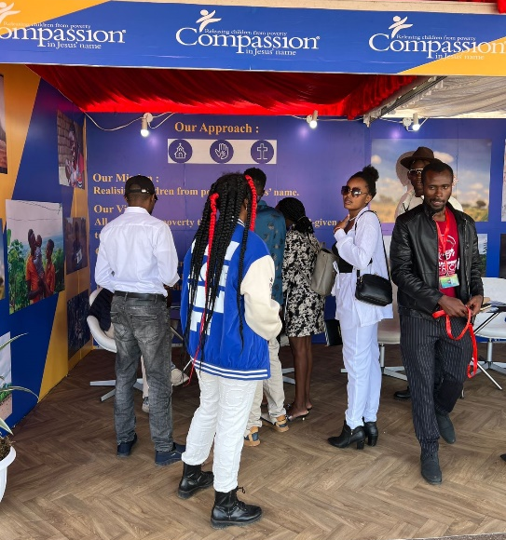
CHALLENGES
Despite the success of MAGTP's participation in the NGO Week at KICC, several challenges were encountered:
- Resource Constraints: Limited financial resources posed challenges in fully capitalizing on networking opportunities and participating in all relevant workshops and seminars.
- Competition: The crowded environment at the NGO Week made it challenging to stand out and effectively communicate MAGTP's unique value proposition to potential partners and sponsors.
- Logistical Issues: Managing logistics such as transportation, accommodation, and scheduling amidst the bustling event posed logistical challenges for MAGTP members.
Addressing these challenges will require strategic planning and resource allocation to optimize future participation in similar events, ensuring MAGTP can maximize its impact and achieve its organizational objectives effectively.
RECOMMENDATIONS
Based on the insights gathered from the NGO Week, MAGTP recommends:
- Continued Engagement: Maintain active participation in similar events to sustain and expand the network of contacts established.
- Capacity Building: Invest in training and development programs for members to leverage new knowledge and skills acquired.
- Strategic Partnerships: Pursue formal partnerships with identified organizations to enhance the impact and reach of MAGTP's initiatives..
CONCLUSION
The NGO Week at KICC was a pivotal event for MAGTP, facilitating valuable connections, knowledge sharing, and potential partnerships with other NGOs. It underscored the importance of collaboration in advancing MAGTP's mission of talent discovery and empowerment across Africa. Moving forward, MAGTP remains committed to leveraging these new relationships and insights to further its impact and expand its reach within the continent's artistic and creative communities.
This report summarizes the impact and outcomes of MAGTP's participation in the NGO Week, highlighting its strategic value in enhancing organizational capabilities and fostering collaboration within the NGO sector.

……………………………….……….END OF REPORT……………………………………………

