Management Africa Got Talent Project
Postal address: P.O Box 358-00100,Nairobi
events@talentafricamanagement.org
inquiries@talentafricamanagement.org
Tel: 0721115111
Location : Safari Park View Estate

TREE PLANTING REPORT
DATE : 10TH MAY 2024
LOCATION: 1ST MUGUMOINI DRIVE
PREPARED BY: GRACE MWANGI(Secretary)

BACKGROUND
Management Africa Got Talent Project (MAGTP) is an innovative non-governmental organization (NGO) dedicated to discovering, nurturing, and empowering talent across the African continent. Founded on the belief that Africa's greatest asset is its people, MAGTP seeks to provide the resources and opportunities necessary for individuals to realize their full potential. By focusing on education, mentorship, and community development, MAGTP aims to foster a new generation of leaders and innovators who will drive Africa's growth and development.
EXECUTIVE SUMMARY
Management Africa Got Talent Project (MAGTP) undertook a tree planting exercise as part of its commitment to environmental sustainability and community engagement. This report details the objectives, highlights, challenges, and outcomes of the initiative, providing recommendations for future efforts. The tree planting exercise not only aimed to enhance the environment but also to integrate ecological awareness into the organization's talent development programs.
OBJECTIVES
This report outlines Managemente Synergy's participation in a government-directed tree planting exercise commemorating the victims of floods. The initiative aimed to honor those who lost their lives in floods while also addressing environmental concerns and fostering community resilience.The report details the objectives, highlights, challenges, conclusions, and recommendations related to this tree planting initiative. MAGTP participation in the government-directed tree planting exercise yielded several significant highlights: 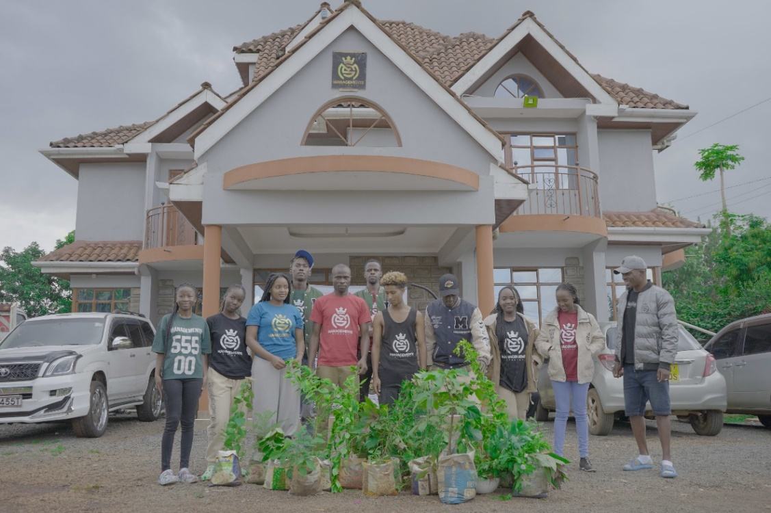
1.Environmental Sustainability : MAGTP aims to contribute to environmental sustainability by participating in tree planting activities. The primary objective is to mitigate the effects of climate change by increasing carbon sequestration and promoting biodiversity through the establishment of tree cover.
2.Corporate Social Responsibility (CSR) : As a responsible corporate citizen, MAGTP recognizes the importance of giving back to the community and supporting initiatives that benefit society. By engaging in tree planting exercises, the company demonstrates its commitment to CSR and environmental stewardship..
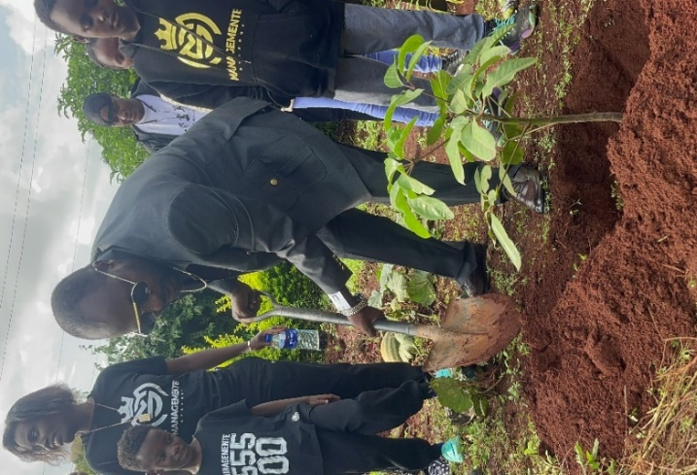
3.Employee Morale and Team Building : Involving employees in tree planting activities promotes teamwork, camaraderie, and a sense of purpose. By participating in meaningful environmental initiatives, employees feel empowered and motivated, leading to improved morale and job satisfaction.
4.Long-Term Impact : MAGTP recognizes the long-term benefits of tree planting for both the environment and society. The objective is to establish a sustainable tree cover that will provide ecological, social, and economic benefits for future generations.
5.Government Compliance :The exercise being a directive from the government, MAGTP objective is to comply with regulatory requirements and fulfill its legal obligations regarding environmental conservation
6.Educational Outreach :Through the tree planting exercise, MAGTP seeks to raise awareness about the importance of environmental conservation and the role of trees in mitigating climate change. The company aims to educate employees, stakeholders, and the broader community about the benefits of tree planting and sustainable land management practices.
7.Enhanced Brand Image :By actively participating in tree planting exercises, MAGTP enhances its brand image as a socially and environmentally responsible organization.
The company's commitment to environmental sustainability and community engagement positively impacts its reputation and relationships with stakeholders.
8.Ecosystem Restoration :In areas where deforestation or environmental degradation has occurred, MAGTP aims to contribute to ecosystem restoration efforts through tree planting. The objective is to rehabilitate degraded lands, improve soil fertility, and restore habitat for wildlife.
9.Measurable Impact : MAGTP sets specific, measurable targets to assess the impact of its tree planting initiatives. Key performance indicators may include the number of trees planted, survival rates, carbon sequestration, community participation levels, and stakeholder satisfaction.
PERFORMANCE OVERVIEW
MAGTP participation in the tree planting exercise has been instrumental in driving positive environmental, social, and corporate outcomes. Here's a comprehensive overview of the company's performance in the tree planting exercise:
1.Strategic Planning and Preparation
MAGTP approached the tree planting exercise with careful strategic planning and thorough preparation. The company conducted comprehensive assessments to identify suitable planting locations, considering factors such as soil quality, biodiversity, and community needs.
Clear objectives and targets were established to guide the initiative, ensuring alignment with the company's environmental sustainability goals and corporate values. Detailed action plans were developed to coordinate logistics, secure resources, and engage stakeholders effectively.
2.Environmental Impact and conservation:
The tree planting exercise has had a significant positive impact on the environment, contributing to ecosystem restoration, biodiversity enhancement, and climate change mitigation.
MAGTP strategic selection of native tree species and planting techniques will help improve soil health and prevent erosion
3.Employee Engagement and Development:
MAGTP prioritized employee involvement in the tree planting exercise, recognizing the importance of employee engagement and development in driving corporate success.
The company provided resources, and support to employees participating in planting activities, fostering a sense of pride, teamwork, and environmental stewardship.
By empowering employees to make meaningful contributions, MAGTP strengthened its organizational culture and employee morale. 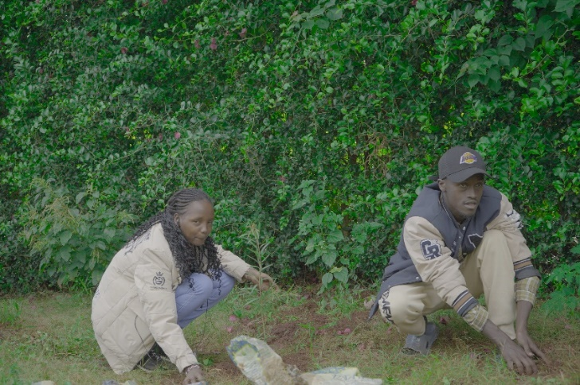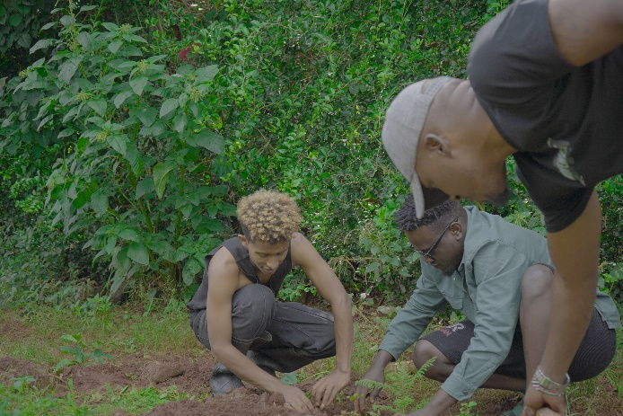
4.Measurement and Evaluation:
MAGTP implemented robust monitoring and evaluation processes to assess the impact and effectiveness of its tree planting efforts.
Key performance indicators, such as the number of trees planted, survival rates, ecosystem services provided, and community feedback, were systematically tracked, analyzed, and reported. This data-driven approach enabled the company to measure progress, identify areas for improvement, and demonstrate accountability to stakeholders.
5.Corporate Reputation and Social Responsibility:
The tree planting exercise has enhanced MAGTP's corporate reputation and social responsibility credentials, positioning the company as a leader in sustainable business practices and community engagement.
By actively participating in initiatives that benefit the environment and society, MAGTP has reinforced its commitment to corporate citizenship and long-term value creation. The initiative has strengthened relationships with customers, investors, and other stakeholders who value companies that prioritize environmental and social impact.
In summary, MAGTP's performance in the tree planting exercise exemplifies its dedication to environmental sustainability, community empowerment, and corporate excellence. Through strategic planning, stakeholder engagement, and measurable outcomes, the company has made a positive and lasting impact on the environment and society.
CHALLENGES
Limited space :Urban areas often have limited available space for tree planting, posing a significant challenge for MAGTP. Identifying suitable planting locations within densely populated urban landscapes requires careful planning and coordination with local authorities and property owners.
Species Selection :Selecting appropriate tree species for urban environments requires careful consideration of factors such as soil conditions, climate suitability, and space constraints. MAGTP must choose species that are resilient, adaptable, and compatible with urban landscapes to ensure long-term success and sustainability.
RECOMMENDATIONS
Based on the experience gained from the tree planting initiative, the following recommendations are proposed for MAGTP:
- Strengthen collaboration with government agencies, local communities, and environmental organizations to streamline planning and implementation processes for future tree planting activities.
- Enhance communication and engagement with affected communities to ensure sensitivity to their needs and preferences.
- Invest in capacity building and training for employees involved in tree planting activities to improve effectiveness and efficiency.
- Implement a monitoring and evaluation framework to assess the impact of tree planting initiatives on environmental restoration and community resilience.
- Continue to actively participate in government-directed initiatives and seek opportunities to further contribute to environmental and social causes
By implementing these recommendations, MAGTP can continue to make meaningful contributions to environmental conservation and community development while reinforcing its commitment to corporate social responsibility.
CONCLUSION
MAGTP's participation in the government-directed tree planting initiative demonstrates its commitment to honoring the memory of flood victims and contributing to environmental restoration efforts. The initiative not only fulfills corporate social responsibility but also promotes community engagement and resilience-building. Despite facing challenges, the positive outcomes highlight the significance of collective action in addressing environmental and social challenges.

…………………………………..END OF REPORT…………………………..

