Management Africa Got Talent Project
Postal address: P.O Box 3-20600,Maralal
Tel: 0707139007
Location : Baraka Estate,Maralal Town

TREE PLANTING REPORT
DATE:10TH MAY 2024
LOCATIONS: SPRINGS OF HOPE CHILDREN’S HOME,SENEIYA SPECIAL SCHOOL & MOI GIRLS HIGH SCHOOL
PREPARED BY: NICKSON KIUGU(Manager)

EXECUTIVE SUMMARY
In response to a government directive commemorating victims of floods and as part of our commitment to environmental stewardship and community engagement, Management Synergy undertook a tree planting initiative at Springs of Hope Children's Home, Seneiya Special School, and Moi Girls Secondary School. This report outlines the significance of planting trees in these specific locations, highlights the importance of commemorating flood victims, and discusses the noble intent behind our initiative. 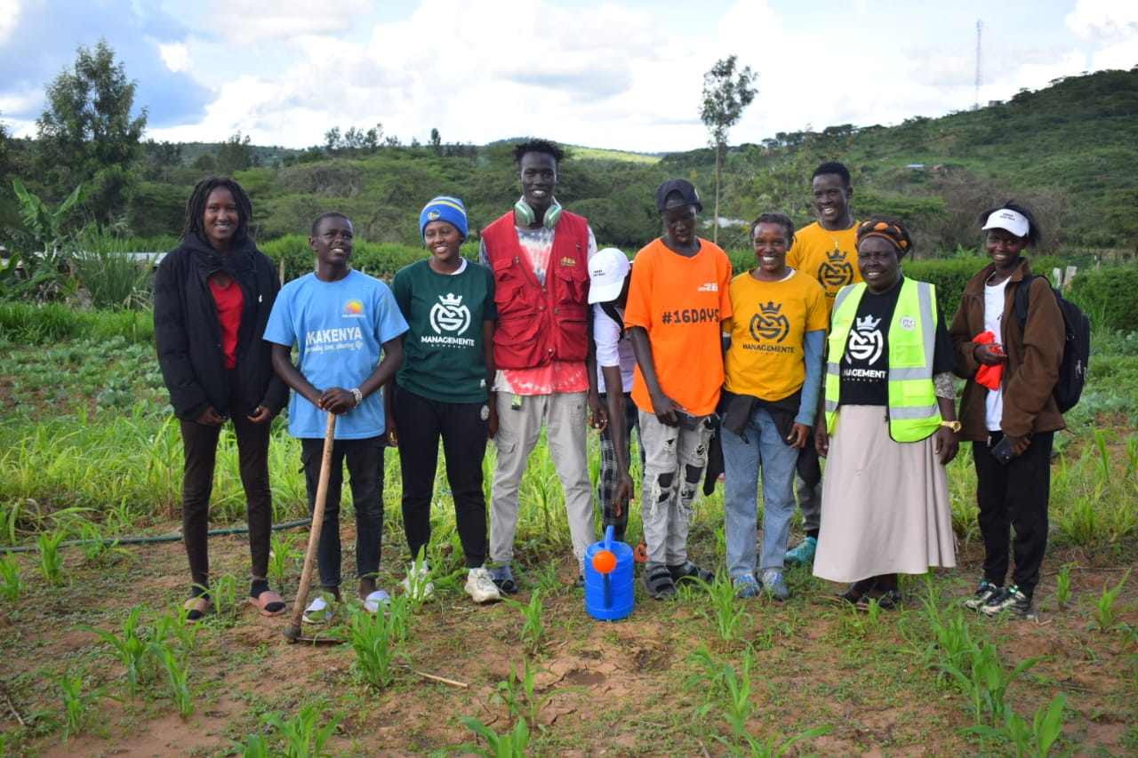
INTRODUCTION
The tree planting initiative was driven by two primary motivations: compliance with a government directive to honor flood victims and our inherent commitment to environmental conservation and community welfare. By selecting Springs of Hope Children's Home, Seneiya
Special School, and Moi Girls Secondary School as planting sites, we aimed to address diverse community needs while paying homage to those affected by natural disasters.
Why Tree Planting Was Important
1.Springs of Hope Children’s Home
- Importance: Children's homes provide sanctuary for vulnerable youths, often lacking green spaces crucial for their well-being and development. Tree planting at Springs of Hope aimed to create a nurturing environment, offering shade, beauty, and opportunities for educational engagement. 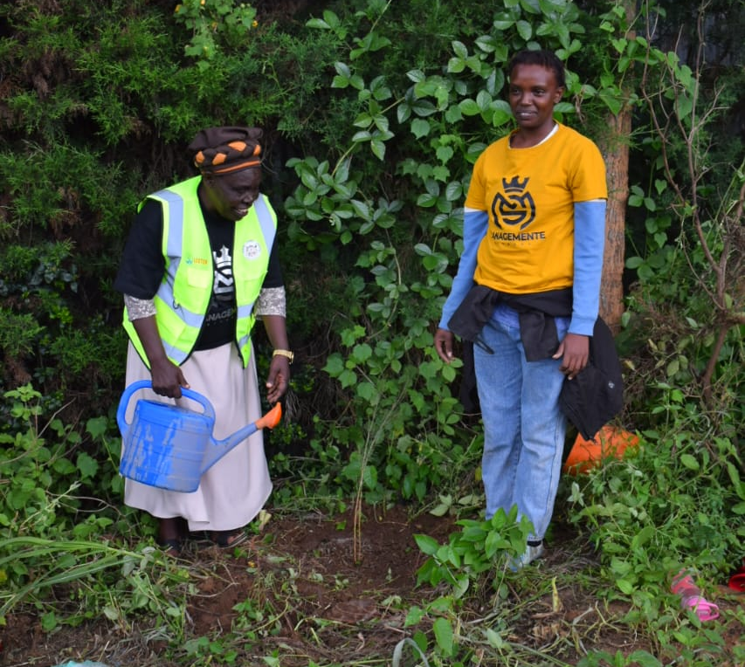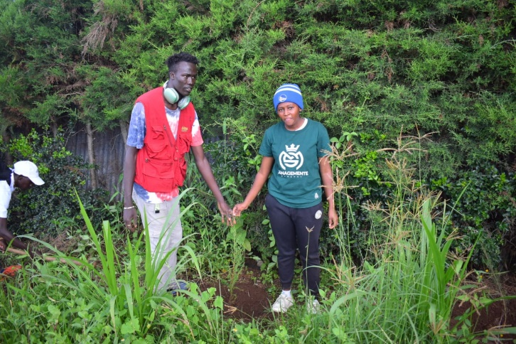
- Significance: By greening the surroundings, we not only fostered a sense of tranquility and belonging but also paid tribute to children and families affected by floods, symbolizing hope and renewal in the face of adversity.
2.Seneiya Special School
- Importance: Special schools cater to students with disabilities, necessitating inclusive outdoor spaces for recreation and learning. Planting trees at Seneiya aimed to provide sensory stimulation, therapeutic benefits, and improved air quality, enhancing the holistic well-being of students and staff.
- Significance: Our initiative at Seneiya not only promoted environmental sustainability but also honored flood victims, acknowledging the resilience and strength of individuals facing diverse challenges. 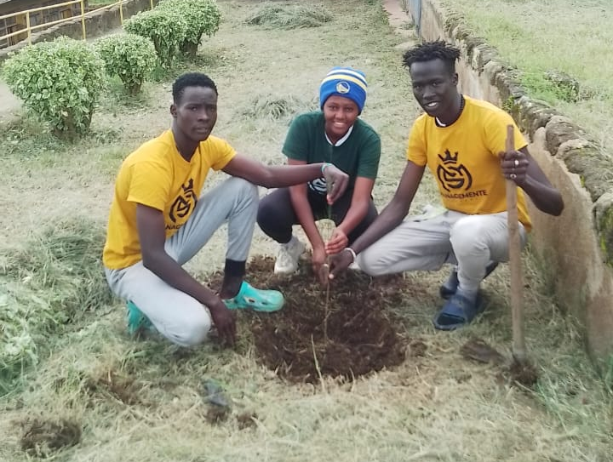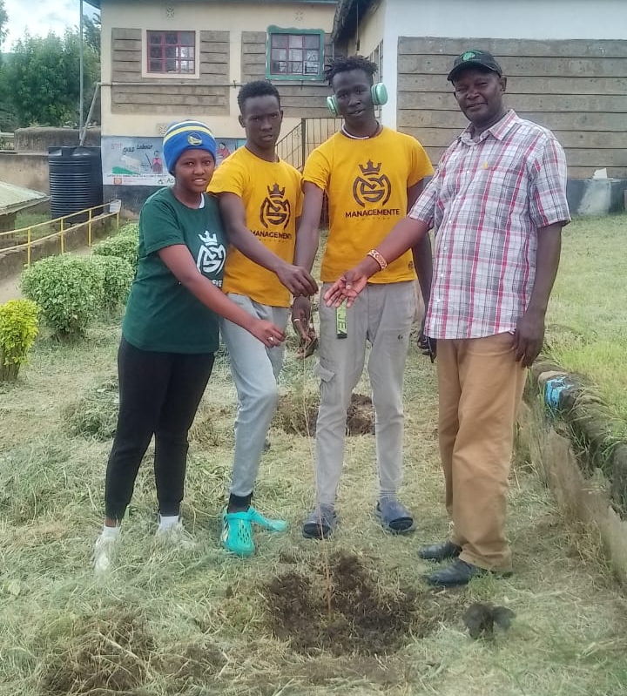
3.Moi Girls Secondary School
Importance: High schools serve as centers of academic excellence and leadership development, requiring conducive environments for holistic student growth. Tree planting at Moi Girls aimed to beautify the institution, provide shade, and offer educational opportunities in environmental stewardship.
Significance: By greening the school grounds, we honored flood victims while inspiring future generations to embrace environmental responsibility, recognizing the interconnectedness of human welfare and ecological health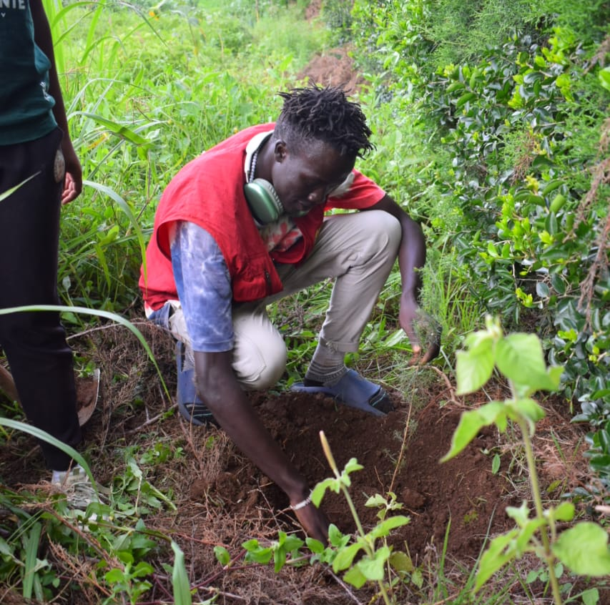.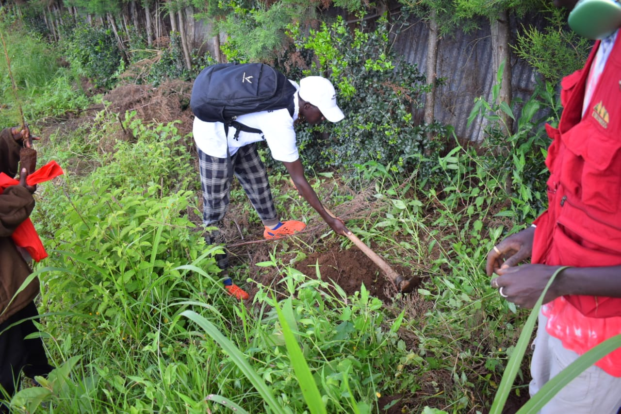
CHALLENGES
Despite our noble intentions, several challenges were encountered during the tree planting initiative, including logistical constraints, resource limitations, and inclement weather conditions. However, through effective planning, collaboration, and perseverance, these challenges were overcome, ensuring the successful implementation of our initiative.
RECOMMENDATIONS
To optimize future tree planting initiatives, the following recommendations are provided:
1.Strengthen partnerships with local authorities, community organizations, and businesses to secure funding and resources for tree planting projects.
2.Conduct thorough site assessments to identify suitable planting locations and ensure the long-term viability of planted trees.
3.Develop comprehensive outreach and education programs to raise awareness about the importance of tree planting, environmental conservation, and disaster resilience.
4.Implement regular monitoring and maintenance protocols to support the growth and survival of planted trees and maximize their environmental and social impact.
CONCLUSION
The tree planting initiative at Springs of Hope Children's Home, Seneiya Special School, and Moi Girls Secondary School reflects MAGTP's unwavering commitment to environmental sustainability, community welfare, and honoring the memory of flood victims. By greening these diverse settings, we not only enhance the physical environment but also nurture hope, resilience, and solidarity within our communities.
As we commemorate the lives lost to natural disasters, let us renew our dedication to building resilient communities, safeguarding the environment, and fostering a brighter future for generations to come.
[End of Report]

