Management Africa Got Talent Project
Postal address: P.O Box 358-00100,Nairobi
events@talentafricamanagement.org
inquiries@talentafricamanagement.org
Tel: 0721115111
Location : Safari Park View Estate

LIL CUSHITE’S MEDIA TOUR
DATE: 7th April 2024 – 27th April 2024
LOCATION: QRATED PODCAST,RADIO 47,CITIZEN TV,RAMOGI TV,NTV,KTN
PREPARED BY: GRACE MWANGI

BACKGROUND
Management Africa Got Talent Project (MAGTP) is a dynamic non-governmental organization (NGO) committed to identifying, nurturing, and empowering talent across Africa. Founded on the belief that talent is abundant but opportunities are scarce, MAGTP aims to create pathways for individuals to develop their skills and achieve their full potential. By fostering a culture of innovation, excellence, and inclusivity, MAGTP plays a pivotal role in the socio-economic development of the continent.
EXECUTIVE SUMMARY
This report outlines the planning, execution, and outcomes of the media tour organized by Managemente Synergy for their artist, Lil Cushite. The tour aimed to promote Lil Cushite's latest projects, engage with media outlets, and increase visibility for both the artist and our organization
. 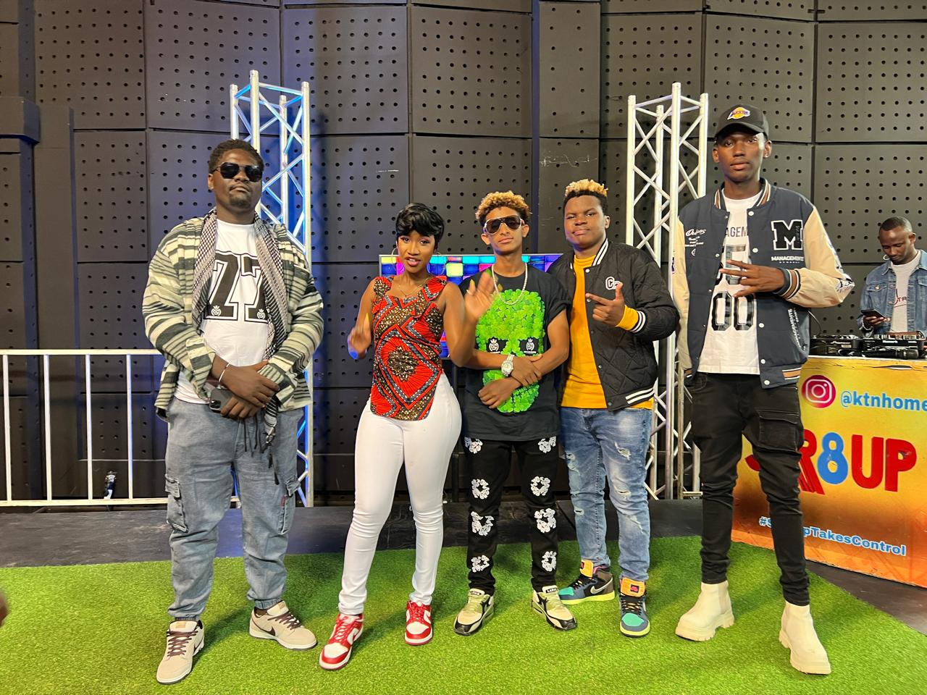
INTRODUCTION
Management Africa Got Talent Project is dedicated to supporting talented artists like Lil Cushite and providing them with opportunities to showcase their work on a global platform. As part of our commitment to artist development and promotion, we facilitated for a media tour to create buzz around Lil Cushite's latest endeavors and strengthen our presence in the entertainment industry.
OBJECTIVES
1.Increase Visibility:
- Objective: To enhance the visibility of Lil Cushite's music and brand by securing media coverage across multiple platforms.
- Strategy: Engage with a diverse range of media outlets, including print, online, radio, and television, to reach a wide audience demographic.
- Tactics: Schedule interviews, features, and performances on prominent media platforms to showcase Lil Cushite's talent and personality.
2.Build Relationships:
- Objective: To establish and nurture relationships with media contacts, influencers, and industry professionals for future collaboration and support.
- Strategy: Cultivate meaningful connections with journalists, bloggers, radio hosts, and social media influencers to build a network of supporters.
- Tactics: Conduct personalized outreach, attend networking events, and participate in meet-and-greet opportunities to foster rapport and goodwill.
3.Generate Buzz:
Objective: To create excitement and anticipation surrounding Lil Cushite's upcoming projects, releases, and events.
Strategy: Generate positive buzz and anticipation through strategic messaging, teaser campaigns, and exclusive content reveals.
Tactics: Utilize social media platforms, press releases, and promotional materials to tease new music, share behind-the-scenes footage, and engage with fans in real-time.
4.Enhance Reputation:
- Objective: To bolster the reputation and credibility of Lil Cushite as an artist and Management Africa Got Talent Project NGO as a reputable organization in the entertainment industry.
- Strategy: Position Lil Cushite as a talented and versatile artist with a unique voice and compelling narrative
.
- Tactics: Showcase Lil Cushite's achievements, accolades, and artistic evolution through media interviews, profiles, and features highlighting his journey and contributions to the music industry.
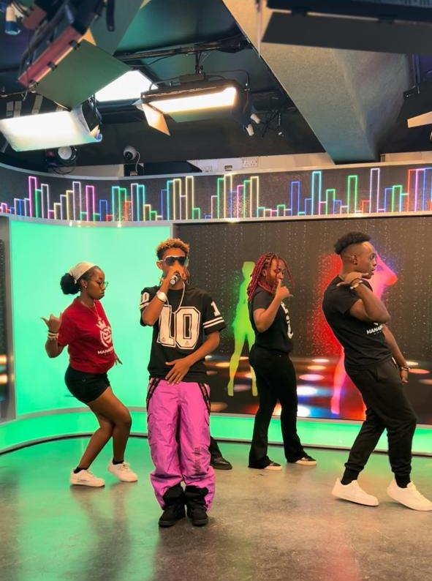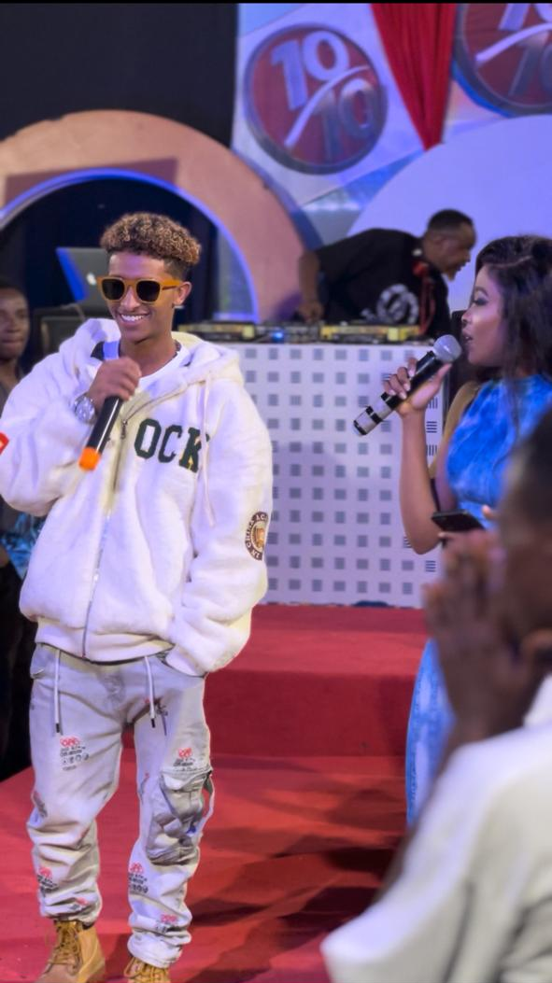
Summary:The objectives outlined above served as guiding principles for the media tour organized for Lil Cushite, aiming to maximize exposure, cultivate relationships, create buzz, and strengthen reputation. By strategically aligning our efforts with these objectives, we were able to achieve significant milestones and lay the groundwork for continued success in Lil Cushite's career and our organization's endeavors in the entertainment industry.
IMPLEMENTATION
Introduction
This is a comprehensive overview of the implementation process of the media tour organized by Managemente Synergy for their esteemed artist, Lil Cushite. The execution of the tour involved meticulous planning, coordination, and execution to ensure maximum impact and success.
1.Pre-Tour Preparation:
- Conducted Research: Researched and identified target media outlets, journalists, and influencers aligned with Lil Cushite's target audience and genre.
- Developed Press Materials: Prepared press releases, artist bios, promotional photos, and other press materials to distribute to media contacts.
- Coordination of Logistics: Arranged transportation and itinerary scheduling for Lil Cushite and accompanying team members.
2.Media Outreach and Engagement:
- Personalized Outreach: Initiated personalized outreach to media contacts via email, phone calls, and social media to pitch interview opportunities and secure coverage.
- Follow-Up Communication: Followed up with media contacts to confirm interview schedules, coordinate logistics, and address any additional requirements or inquiries.
- Relationship Building: Cultivated relationships with journalists, bloggers, radio hosts, and influencers through networking events, meetings, and engaging conversations
- . 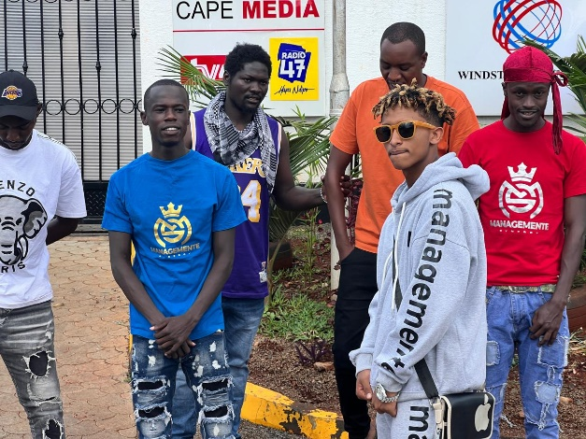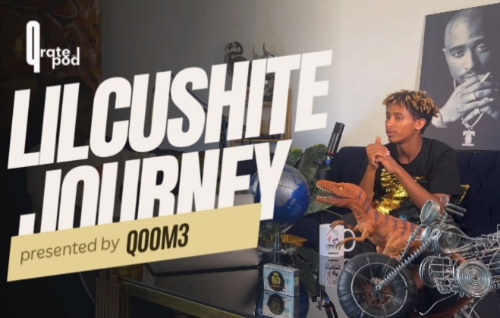
3.Tour Activities:
- Interviews and Features: Participated in interviews, features, and profiles with various media outlets, including print, online, radio, and television, to promote Lil Cushite's music and projects.
- Radio and Podcast Appearances: Made guest appearances on radio shows and podcasts to discuss Lil Cushite's latest releases, inspirations, and future plans.
- Live Performances and Events: Showcased Lil Cushite's talent and stage presence through live performances at select tv shows
4.Social Media and Online Engagement:
- Social Media Strategy: Implemented a strategic social media plan to complement the tour activities and engage with fans, followers, and influencers in real-time.
- Content Creation: Generated engaging content, including photos, videos, and live updates, to document Lil Cushite's journey during the tour and share exclusive behind-the-scenes moments.
- Interaction and Engagement: Responded to comments, messages, and mentions from fans and followers across social media platforms to foster community engagement and support.
5.Post-Tour Follow up:
Thank-You Notes: Sent personalized thank-you notes and expressions of gratitude to media contacts, event organizers, and partners for their support and collaboration during the tour.
Evaluation and Analysis: Conducted a comprehensive evaluation of the tour's outcomes, including media coverage, social media metrics, fan engagement, and overall impact, to assess effectiveness and inform future strategies.
Summary:The successful implementation of the media tour for Lil Cushite demonstrates Management Africa Got Talent Project commitment to promoting and supporting talented artists on a global scale. Through strategic planning, proactive outreach, engaging activities, and post-tour analysis, we were able to effectively amplify Lil Cushite's music and brand, strengthen relationships with media contacts and industry stakeholders, and elevate our organization's presence in the entertainment industry.
CHALLENGES
1.Scheduling Conflicts:
Description: Coordinating interviews, appearances, and performances amidst conflicting schedules posed a significant challenge. Some media outlets had limited availability or conflicting time slots, making it difficult to secure desired coverage.
Impact: The inability to accommodate all media requests and opportunities limited the tour's reach and potential impact, affecting Lil Cushite's exposure and promotional efforts.
2.Travel Logitics:
Description: Managing travel logistics, including transportation arrangements proved challenging.Delays,cancellations and some vehicles had mechanical issues hence disrupting the tour itinerary and caused inconvenience for Lil Cushite and the accompanying team.
Impact: Travel disruptions hindered timely arrivals, resulting in missed opportunities for interviews, performances, and media engagements. This adversely affected the tour's efficiency and effectiveness in maximizing exposure and engagement.
3.Media Engagement:
Description: Engaging with media outlets and securing coverage proved challenging due to varying levels of interest, response rates, and communication barriers. Some media contacts were unresponsive or disinterested, making it challenging to generate significant traction and visibility.
Impact: Limited media engagement resulted in fewer opportunities for exposure and promotion, affecting the tour's overall success in reaching target audiences and achieving promotional objectives.
4.Competing Priorities:
Description: Balancing the media tour commitments with other professional obligations, personal commitments, and unforeseen emergencies presented challenges for Lil Cushite and the tour team. Prioritizing engagements and managing time effectively became increasingly difficult amidst competing priorities and responsibilities.
Impact: Overcommitment, fatigue, and stress levels among Lil Cushite and team members affected their performance, energy levels, and overall morale during the tour. This impacted the quality of interactions, engagements, and deliverables, diminishing the tour's impact and effectiveness.
Summary:Despite encountering several challenges during the media tour for Lil Cushite, Management Africa Got Talent Project remains committed to addressing these obstacles and optimizing future initiatives for greater success. By identifying, acknowledging, and learning from these challenges, we can refine our strategies, improve our execution, and enhance our ability to promote and support talented artists like Lil Cushite effectively.
RECOMMENDATIONS
1.Enhance Pre-Tour Planning:
Conduct comprehensive research to identify target media outlets, influencers, and key stakeholders.
Develop a detailed itinerary and contingency plan to mitigate scheduling conflicts and logistical challenges.

2.Strengthen Media Engagement:
Implement a proactive outreach strategy to cultivate relationships with media contacts and influencers.
Provide media training and resources to ensure effective communication and engagement during interviews and appearances.
3.Optimize Travel Logistics:
Partner with reputable travel agencies and logistics providers to streamline transportation
Anticipate and prepare for potential travel disruptions by maintaining open communication and flexibility.
4.Evaluate and Adapt:
Conduct post-tour evaluations to assess the tour's outcomes, including media coverage, audience engagement, and impact on Lil Cushite's career.
Use feedback and insights gathered to refine future tour strategies and optimize promotional efforts.
Summary: In conclusion, the media tour for Lil Cushite has been a valuable opportunity to showcase his talent, connect with audiences, and further establish Management Africa Got Talent Project as a supporter of artistic excellence. By implementing the recommendations outlined above and building upon the successes of this tour, we are confident in our ability to continue promoting and supporting talented artists like Lil Cushite on a global scale.
CONCLUSION
The media tour organized for Lil Cushite, in collaboration with Management Africa Got Talent Project, marks a significant milestone in the promotion and exposure of our talented artists. Despite encountering challenges along the way, the tour achieved notable successes in enhancing Lil Cushite's visibility, engaging with media outlets, and fostering connections within the entertainment industry.
Throughout the tour, Lil Cushite showcased his talent, charisma, and dedication to his craft, leaving a lasting impression on audiences and industry professionals alike. The tour not only elevated Lil Cushite's profile but also strengthened our organization's reputation as a leading supporter of emerging talent in the entertainment industry.
Despite the challenges faced, the tour's outcomes are a testament to the dedication, perseverance, and teamwork demonstrated by all involved parties. As we reflect on the achievements and lessons learned from the tour, it is imperative to identify areas for improvement and outline recommendations to enhance future initiatives.

………………………. END OF REPORT…………………………

